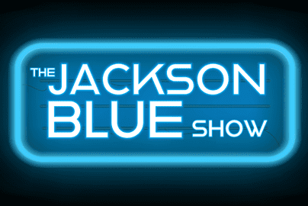
LINEAR CLOCK
Last updated: 10/18/24
1- Hello break
2- Stand alone or tease to next break
3- Caller (usually generic but sometimes teased for content)
4- Stand alone content
5- Plug shout out line and shout outs of the day
6- Stand Alone Content Break OR Tease Ahead
7- Topic setup - usually 20 seconds or so - solicit for calls/interaction
8- Caller on topic
9- Tease forward to continue topic OR stand-alone break
10- Stand Alone Content Break OR Tease Ahead
11- CALLER
12- Generic stand alone break
13- Tease next caller/setup question/etc.
14- CALLER (following up on last break)
15- Plug Shout Outs/Shout Out Line
16- Stand Alone Content Break OR Tease Ahead
17- CALLER
18 - Stand Alone Break
19- Tease next caller/setup question/etc.
20- CALLER (following up on last break)
21- Plug Shout Outs/Shout Out Line coming up in 20 minutes
22- Stand Alone Content Break OR Tease Ahead
23- Shout Outs are NEXT - Last call to make 'em!
24- SHOUTOUT PLAYBACKS
25- Plug Request of Love and Devotion this hour
26- CALLER (usually generic)
27- Stand Alone Content Break OR Tease Ahead
28- Thanks for listening - Request of Love & Devotion is NEXT!
29- Read Request of Love and Devotion (always kept generic so you can
play whatever song for it)

